Lab Assignment 7: File Encryption and Decryption using Python Cryptography Library
Name: Harshit Kumar More
Roll No. - 16

Tasks:
1. Install and import the cryptography library.
pip install cryptography
from cryptography.fernet import Fernet

2. Generate a symmetric key using Fernet
key = Fernet.generate_key()
with open("secret.key", "wb") as key_file:
key_file.write(key)

with open("data.txt", "w") as file:
file.write("This is a confidential file.")

3. Encrypt a given text file using the symmetric key
with open("secret.key", "rb") as key_file:
key = key_file.read()

f = Fernet(key)

# Read file
with open("data.txt", "rb") as file:
data = file.read()

# Encrypt
encrypted_data = f.encrypt(data)

# Save encrypted file
with open("encrypted.txt", "wb") as file:
file.write(encrypted_data)

print("File Encrypted Successfully")

4. Decrypt the encrypted file and verify correctness.
with open("secret.key", "rb") as key_file:
key = key_file.read()

f = Fernet(key)

# Read encrypted file
with open("encrypted.txt", "rb") as file:
encrypted_data = file.read()

# Decrypt
decrypted_data = f.decrypt(encrypted_data)

# Save decrypted file
with open("decrypted.txt", "wb") as file:
file.write(decrypted_data)

print("File Decrypted Successfully")

5. Generate RSA public and private keys.
from cryptography.hazmat.primitives.asymmetric import rsa
from cryptography.hazmat.primitives import serialization

# Generate keys
private_key = rsa.generate_private_key(
public_exponent=65537,
key_size=2048
)
public_key = private_key.public_key()
# Save private key
with open("private.pem", "wb") as f:
f.write(private_key.private_bytes(
encoding=serialization.Encoding.PEM,
format=serialization.PrivateFormat.PKCS8,
encryption_algorithm=serialization.NoEncryption()
))
# Save public key
with open("public.pem", "wb") as f:
f.write(public_key.public_bytes(
encoding=serialization.Encoding.PEM,
format=serialization.PublicFormat.SubjectPublicKeyInfo
))
print("RSA Keys Generated")

6. Encrypt a file using the RSA public key.
from cryptography.hazmat.primitives.asymmetric import padding
from cryptography.hazmat.primitives import hashes

# Load public key
with open("public.pem", "rb") as f:
public_key = serialization.load_pem_public_key(f.read())

# Read file
with open("data.txt", "rb") as file:
data = file.read()

# Encrypt
encrypted = public_key.encrypt(
data,
padding.OAEP(
mgf=padding.MGF1(algorithm=hashes.SHA256()),
algorithm=hashes.SHA256(),
label=None
)
)

with open("rsa_encrypted.txt", "wb") as f:
f.write(encrypted)

print("RSA Encryption Done")

7. Decrypt the file using the RSA private key.
with open("private.pem", "rb") as f:
private_key = serialization.load_pem_private_key(f.read(), password=None)

# Read encrypted file
with open("rsa_encrypted.txt", "rb") as f:
encrypted = f.read()

# Decrypt
decrypted = private_key.decrypt(
encrypted,
padding.OAEP(
mgf=padding.MGF1(algorithm=hashes.SHA256()),
algorithm=hashes.SHA256(),
label=None
)
)

with open("rsa_decrypted.txt", "wb") as f:
f.write(decrypted)

print("RSA Decryption Done")

8. Compare execution time and performance of symmetric vs asymmetric encryption.
import time
from cryptography.fernet import Fernet
from cryptography.hazmat.primitives.asymmetric import padding
from cryptography.hazmat.primitives import hashes
from cryptography.hazmat.primitives import serialization

# Re-initialize Fernet object 'f' and ensure other variables are loaded
# Load key
with open("secret.key", "rb") as key_file:
key = key_file.read()
f = Fernet(key)

# Read file data again
with open("data.txt", "rb") as file_data:
data = file_data.read()

# Load public key again (using a different file variable name to avoid conflict)
with open("public.pem", "rb") as public_key_file:
public_key = serialization.load_pem_public_key(public_key_file.read())

# Symmetric timing
start = time.time()
f.encrypt(data)
end = time.time()
print("Fernet Time:", end - start)

# RSA timing
start = time.time()
public_key.encrypt(
data,
padding.OAEP(
mgf=padding.MGF1(algorithm=hashes.SHA256()),
algorithm=hashes.SHA256(),
label=None
)
)
end = time.time()
print("RSA Time:", end - start)

9. Demonstrate secure key storage and handling
- Store keys in .pem or .key files
- Never hardcode keys in code
- Use password protection:
serialization.BestAvailableEncryption(b'mypassword')

Screenshot:
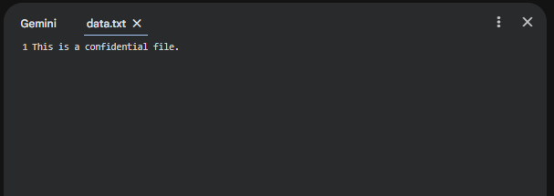
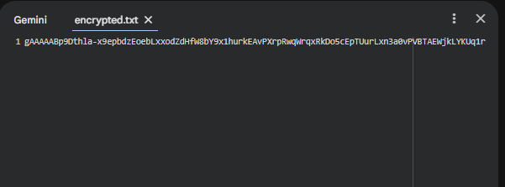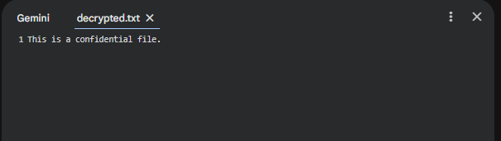
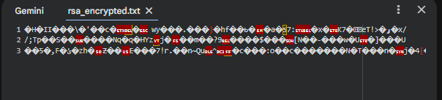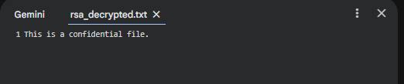
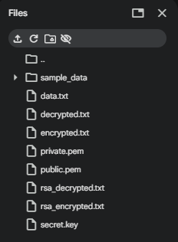
Output Comparison time:


Report:

Objective:
To implement file encryption and decryption using symmetric (Fernet) and asymmetric (RSA) cryptography.

Result:
- Successfully encrypted and decrypted files using both methods.
- Symmetric encryption was faster than RSA.
- RSA provides better key security but is slower.

Conclusion:
Symmetric encryption is efficient for large data, while asymmetric encryption is secure for key exchange.

